Name

Date Pd

Scientific Methods Worksheet 3: Graphical Analysis
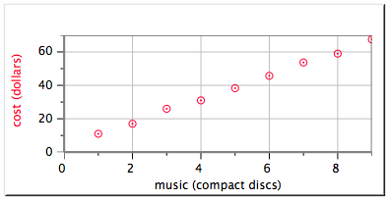
1. A friend prepares to place an online order for CD's.
Slope = 7
y-intercept = 3.6
a. What are the units for the slope of this graph?

b. What does the slope of the graph tell you in this situation?

c. Write an equation that describes the graph.

d. Provide an interpretation for what the y-intercept could mean in this situation.

2. The following times were measured for spheres of different masses to be pushed a distance of 1.5 meters by a stream:

Mass (kg) | Time (s)
5 | 10.2
10 | 17.3
15 | 23.8
20 | 31.0

a. Graph the data by hand on the grid provided and write a mathematical model for the graph that describes the data.

b. Write a clear sentence that describes the relationship between mass and time.
3. A student performed an experiment with a metal sphere. The student shot the sphere from a slingshot and measured its maximum height. The sphere was shot six times at six different angles above the horizon.
a. What is the relationship being studied?

b. What is the independent variable in this experiment?

c. What is the dependent variable in this experiment?

d. What variables must be held constant throughout this experiment?

4. a. What type of relationship does this graph suggest?

b. What variables would you plot to linearize the data?

5. Consider the graph at right.
a. Write a mathematical expression that describes the relationship.

b. Provide an interpretation for the y-intercept.

c. Using the equation, predict how many applications would be needed to earn $8000.

6. For each of the following graphs:
- Describe how you would linearize the graph.
- Assuming a linear test plot results, write the equation that would describe the straight line produced.
a.
x
y
y
x
y
x

b.

c.

7. The graph below compares the amount of time it takes a planet to orbit the sun (in earth days) versus the distance the planet is from the sun, measured in Astronomical Units.
(1 AU = earth to sun separation.)
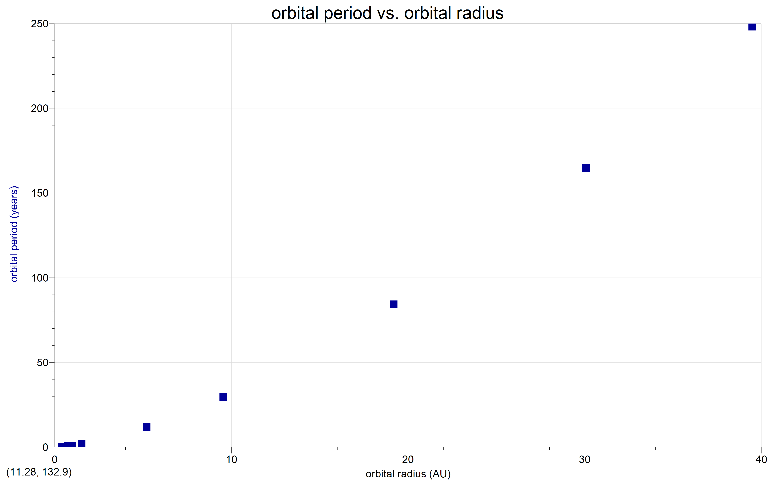
a. What test plot would you try first in order to linearize the relationship below?

b. In this case it turns out that several test plots need to be made before the graph is linearized. (Johannes Kepler was the first person to work out this relationship in the early 1600's.) Write the equation for the graph below. Does the same equation apply to the graph above? Why?


