Volume and Surface Area of Cones, Spheres, and Cylinders
Sweet Treats Activity
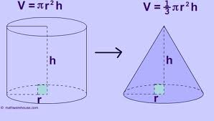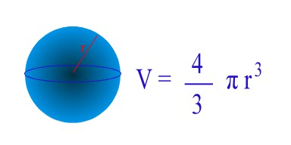

Find the volume of each item. Use millimeters (mm) as the unit of measurement. Show your work.
Sugar Cone
Radius: _____________
Height: ______________

Volume: _____________

Whopper Ball Candy
Radius: _____________

Volume: _____________

Chocolate Round Cake
Radius: _____________
Height: _____________

Volume: _____________
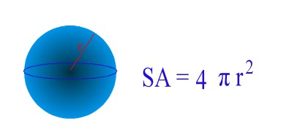
Now find the surface area of each item. Use millimeters (mm) as the unit of measurement.
Show your work.
Sugar Cone
Radius: _____________
S: ______________
Surface Area: _____________

Whopper Ball Candy
Radius: _____________
Surface Area: _____________

Chocolate Round Cake
Radius: _____________
Height: _____________
Surface Area: _____________

How many whopper candies does it take to equal the volume of the sugar cone?

How many round cakes does it take to equal the volume of a sugar cone?

How many whopper candies does it take to equal the surface area of the sugar cone?

How many round cakes does it take to equal the surface area of the sugar cone?

