**PhET** - **Angry Birds Name:**

Use the PhET website http://phet.colorado.edu/en/simulation/projectile-motion

Using the Angry Birds Videos or PhET website, explore projectile motion and answer these questions:

**Type up your answers and change the title of the file to include your LAST NAME.**

1. How do you get a projectile to travel the farthest? (Use the PhET simulation.)

2. Can you find multiple launch angles that will land on the same spot? What is true about those angles if they exist? (use the PhET simulation and look at the horizontal line the extends from the cannon to compare how far they travelled.) Use the tape measure to find the range (horizontal distance).

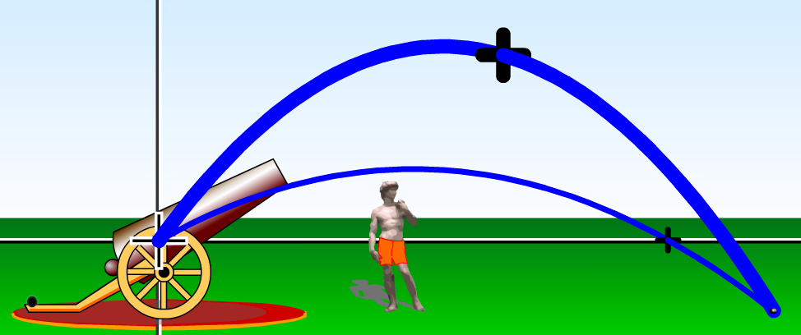

**THIS IS AN EXAMPLE OF NOT LANDING AT THE SAME SPOT. Look at the horizontal line.**

3. What happens when you launch a projectile at the same angle but change the initial velocity? (Use the PhET simulation.)

4. What happens when you launch a projectile at the same velocity but change the initial angle? (Use the PhET simulation.)

5. What launch angles have the longest time in flight? (Use the PhET simulation.)

6. What launch angles have the shortest time in flight? (Use the PhET simulation.)

7. What did you notice about the movement and behavior of the birds and the objects that they collided with? How the objects fall, rock, bounce, etc? (Use Angry Birds Videos here.)

8. What is the acceleration due to gravity (g) in the Angry Birds world? (Explain how you would figure this out. Use the movies posted on tigerphysics.org and LoggerPro. What measurements would you have to make?)

Procedure:

Data

1. 9.
2. a.)What do you need to know to solve this?

b.)Is there any information that you would have to make an assumption to help figure this out?

10. Do different birds have different accelerations due to gravity or is g the same for every bird on a particular level?