Balancing Act Lab Activity 1 Name__________________________________
Learning Goals: Students will be able to determine the variables that affect the balancing of a seesaw and predict where an object of a certain mass will have to be placed to balance the seesaw.
Directions: Log in to http://www.colorado.edu/physics/phet and click on Physics in the left hand column and then choose the Balancing Act icon. Choose “Run Now” to start the simulation.
- Investigate Balancing Act using the Intro tab at the top by moving the tanks and trash cans around and removing the supports to try to balance the seesaw. While you play with this tool, make observations about when the beam balances and when it doesn’t. Use the tools on the side (mass labels, rulers, forces from objects and the level) to help you make your observations. Describe what you discovered about balancing the seesaw.

- Use the scenarios below to make predictions about where the 10kg trash can would need to be placed, without using Balancing Act. Sketch what you think the beams would look like for the following scenarios and justify your reasoning.
Scenario 1:
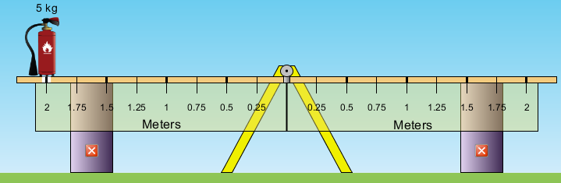
Justification:
Scenario 2:
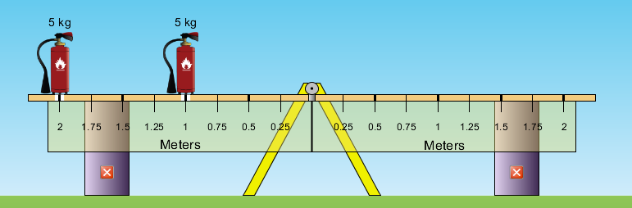
Justification:

Scenario 3:
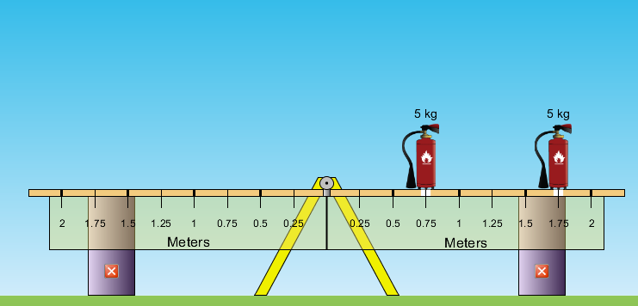
Justification:
- Now, use the Balancing Act simulation to verify or correct your predicted scenarios and justification with a different color pen.
Next, click on the Game tab in the upper left. Try several scenarios at the different levels for a minute or two each.
- What did you learn by playing the game?

- Explain what factors affect the balancing of the beam and describe how each factor appears to affect the balancing.

- Now suppose you go to the park with a younger, smaller child. How would you use this information so the two of you could use the seesaw even though you are not the same size?

Balancing Act Activity 2 Name ___________________________
Learning Goal: Students will calculate where a mass needs to be placed on a beam to balance the beam and then confirm or correct their calculations using the Balancing Act simulation.
Investigation:
- Calculate where the 80 kg man would need to sit to balance the beam. Show all work including formulas and substitutions with units.

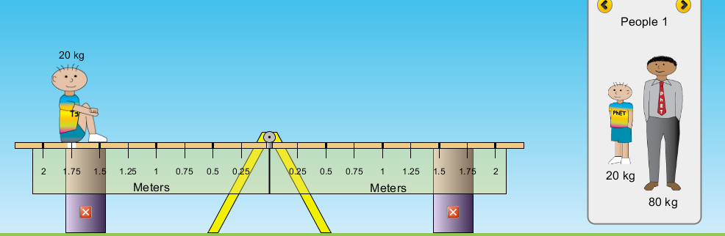
Click on the Balance Lab tab on the upper left of the simulation and test your calculations. You may need to use the yellow arrows in the brick box to scroll to the man and child. Evaluate your calculations. (How’d you do?)

- Predict where you would place the 20kg pile of bricks to balance the beam? Show all calculations including formula and substitutions with units.
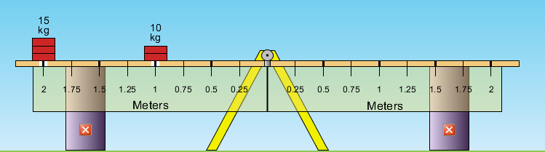
Now test your predictions and calculations using the Balance Lab tab. Evaluate your calculations.

- Calculate where a 15kg pile of bricks would need to be placed to balance the beam. Show all calculations.
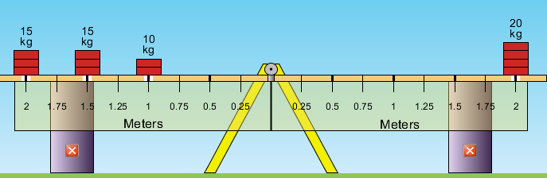
Evaluate your calculations using the simulation.

Finally, using the Balancing Lab tab and scrolling to the mystery packages, determine the mass of each package. Show all work including formulas and substitutions with units.
Package | Calculation | Where did you place the package on the beam?

