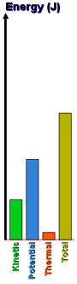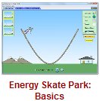**The Skate Basic Park – Intro to Energy Potential and Kinetic PhET Lab**

**Introduction:**

When Tony Hawk wants to launch himself as high as possible off the half-pipe, how does he achieve this? The skate park is an excellent example of the **conservation of energy**. The law of conservation of energy tells us that we can never create or destroy energy, but we can change its form. In this lab, we will look at the conversion of energy between *gravitational-****potential*** energy, work, and ***kinetic*** (or moving) energy.

Use the internet, your textbook, or notes to define the following key terms:

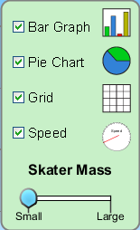

Kinetic Energy ________________________________________________________________________

Potential Energy _______________________________________________________________________

Mechanical Energy ____________________________________________________________________

Joule ________________________________________________________________________________

State, in **your own words**, the **Law of the Conversation of Energy**. _____________________________

____________________________________________________________________________________

**Procedure:** *PheT Simulations 🡪 Play With Sims 🡪 Physics 🡪 Energy Skate Park:* ***Basics*** 

**Take some time and play with the skater. Turn on the Bar Graph, Pie Chart, and Speed options.**

How does increasing skater's **mass** change the skater’s….

Kinetic Energy? ____________________Potential Energy? ____________________Total Energy? _____________________

How does the skater’s **kinetic energy** change as he moves **down** the ramp? _________________________________________

How does the skater’s **kinetic energy** change as he moves **up** the ramp? ___________________________________________

How does the skater’s **potential energy** change as he moves **down** the ramp? _______________________________________

How does the skater’s **potential energy** change as he moves **up** the ramp? __________________________________________

How does the skater’s **total energy** change as he moves **down** the ramp? ___________________________________________

How does the skater’s **total energy** change as he moves **up** the ramp? _____________________________________________

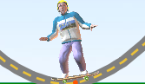Describe the skater’s **kinetic** energy at the bottom of the ramp. _____________________________________

Describe the skater’s **potential** energy at the bottom of the ramp. ___________________________________

What happens when the skater is dropped onto the ramp from above the ramp? ______________________________________

Observe the following situations. Draw the possible bar graphs for the situation shown. Compare your results with a nearby lab group, AFTER you have completed this section.

|  |  |  |  |
| --- | --- | --- | --- |
| Top of the ramp, stopped for just an instance. |  | Bottom of the ramp, zooming past the middle. |  |
| Mid-way down the ramp, moving about mid-speed. |  | 3/4 of the way down the ramp, moving pretty fast. |  |

Draw where the skater might be based on the bar graphs shown. Compare your results with a nearby lab group, AFTER you have completed this section.

|  |  |  |  |
| --- | --- | --- | --- |
|  |  |  |  |
|  |  |  |  |

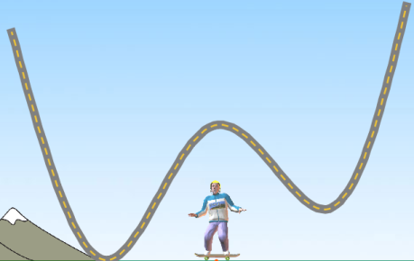

**A**

**←** Consider this zany track. What point or points on this track would the skater have ...

The most kinetic energy? The most potential energy?

**E**

**D**

The same kinetic energy (two points) and

**B**

**C**

**Conclusion Questions: (*circle the correct answers*)**

1. At the highest point kinetic energy is *zero / maximum* while the potential energy is *zero / maximum*.
2. At the lowest point kinetic energy is *zero / maximum* while potential energy is *zero / maximum*.
3. Mass *affects / does not affect* the amount of energy.
4. As an object falls in gravity, kinetic energy *increases / decreases / remains the same*.
5. As an object falls in gravity, potential energy *increases / decreases / remains the same*.
6. As an object falls in gravity, total energy *increases / decreases / remains the same*.
7. An object travelling faster and faster has a kinetic energy that *increases / decreases / remains the same*.
8. An object travelling faster and faster has a potential energy that *increases / decreases / remains the same*.
9. As an object speeds up, the total energy *increases / decreases / remains the same.*
10. As an object slows down, the total energy *increases / decreases / remains the same.*