Part I: Locate the epicenter of the earthquake by using the information provided below.

- Fill in the Table, using your Earth Science Reference Tables as needed.
- Using a compass, draw the correct circles around each of the three cities on the map.

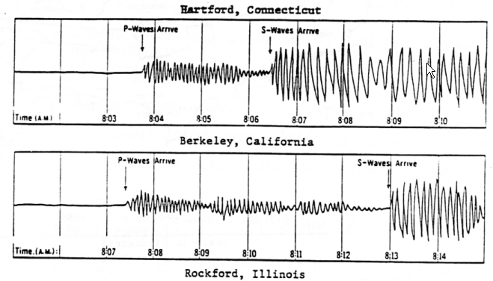
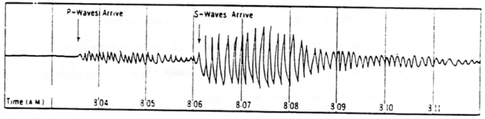

TABLE OF DATA FROM SIMULATED SEISMOGRAMS
Seismographic Station | Arrival of P-Waves | Arrival of S-Waves | Time Interval Between Arrivals | Distance to Epicenter
Hartford, Conn.

Berkeley, Calif.

Rockford, Illinois

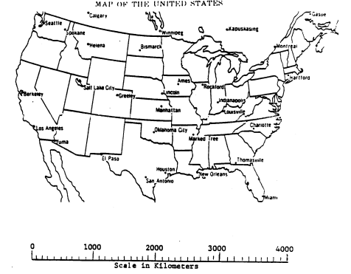
Questions

1. In which state of the U.S. did this earthquake occur?

2. Near which city on the map did this earthquake occur?

3. Which STATION was farthest away from the epicenter?

4. How far away was that STATION?

5. What is a seismograph?

6. Data from how many stations is needed to locate an epicenter?
7. List the three types of seismic waves and the properties of each. Include relative speed and what types of materials each can or cannot travel through.
Part II:
Define Strike:
Define Dip:
Find the strike and dip information using these symbols:
a. b. 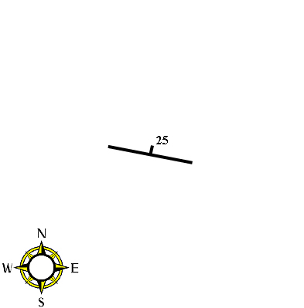
c. d.
Draw strike and dip for:
a. N15E and 25NW b. N75W and 15SW

