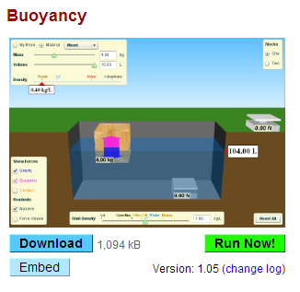
Part 1 – Buoyancy
http://phet.colorado.edu/en/simulation/buoyancy
- Open the web browser and enter the link above into the address bar.
- When the simulation page opens click “Run Now!”
- Click the “Buoyancy Playground” tab at the top of the window.
- Look in the yellow data box in the top left corner of the window. Record the mass (m), volume (V), and density (ρ) of the wood block.
- In the middle of the screen there is a container of water. Record the volume of the water.
- Drop the wood block into the water. Does the wood block float? Explain why or why not.
- Place the block so that it is completely submerged in the water. Now what is the volume of the water? By how much did it change?
- Write a statement about the volume of an object and the volume of liquid displaced.
- Use the dropdown menu in the yellow data box to change the material of the block to Aluminum. Record the mass (m), volume (V), and density (ρ) of the aluminum block.
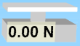
- The white box with “0.00N” Printed on it is a scale, which measured the weight (in Newtons) of whatever is placed on it. What is the weight of the aluminum block on dry land?
- Place the aluminum block in the water. Does it float? Explain why or why not.
- Set the aluminum block on top of the scale. What is the weight of the aluminum block under water?
- How does the weight of the aluminum block under water compare with the weight on dry land? Provide an explanation for why this is so.
- What is the name of the force exerted on an object by a fluid in which it has been placed?
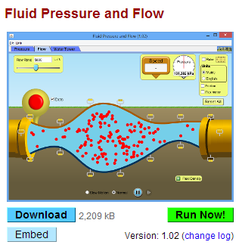
Part 2 – Motion of Fluids
http://phet.colorado.edu/en/simulation/fluid-pressure-and-flow
- Enter the link above into the address bar. When the web page opens click “Run Now!”
- Above the spigot there is a sliding tab. Move the tab to the right to fill the tank up completely with water.
- In the top right corner of the window you can click and drag a pressure gauge to any location on the screen. The bottom of the gauge is the point where pressure is measured.
- Measure and record the pressure of the water at the surface, in the middle, and at the bottom of the tank of water.
- Write a statement about the relationship between pressure and depth in a liquid.
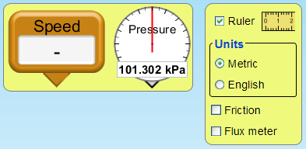
- Click the “Flow” tab at the top of the window. In the top right corner there are pressure and speed gauges that can be dragged to any location on the screen. Clicking the check box next to “Ruler” in the yellow box at the top right of the screen will cause a ruler to appear.
- Measure and record the diameter of the pipe as well as the pressure and speed of the water flowing through the pipe.
- The handles on various parts of the pipe can be clicked and dragged to change the diameter of the pipe at each location. Manipulate the pipe diameter at different locations so that one part has a very narrow diameter and the other part has a wide diameter.
- Measure and record the diameter, speed, and pressure at a point where the pipe is very narrow and at a point where the pipe is very wide.
- Write a statement about the relationship between the diameter of a pipe and the speed of the fluid flowing through it.
- Write a statement about the relationship between the speed and pressure of a fluid in motion.

