Name:
Hang Time Activity
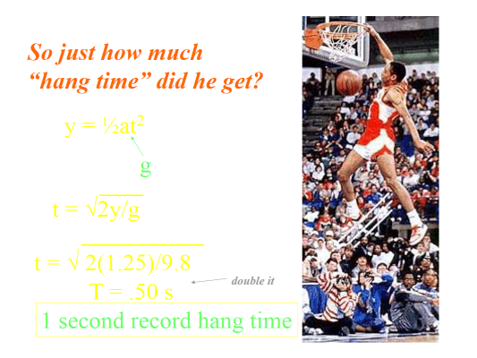

Y = ‘length of the vertical jump’ (must be measured in meters)
g = ‘acceleration due to gravity’ or 9.8 m/s^2
t = hang time in the air

SHOW YOUR WORK!

Person 1 Vertical:____________

Person 1 Hang Time: _______________

Person 2 Vertical:____________

Person 2 Hang Time: _______________

Person 3 Vertical:____________

Person 3 Hang Time: _______________

Person 4 Vertical:____________

Person 4 Hang Time: _______________

