Name:
Class:

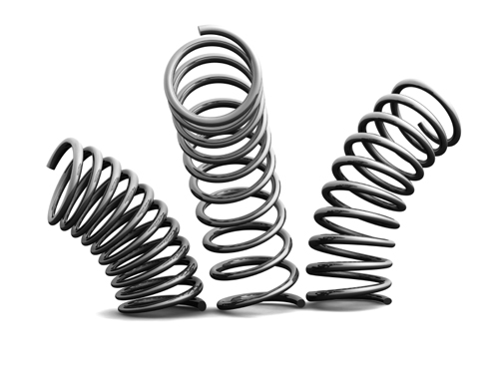
Objectives:
- Determine the spring constant of an unknown spring.
- Determine the mass of unknown objects using Hooke’s Law.
- Determine the potential energy stored in a spring using varying masses.
- Determine the period of oscillation of a spring undergoing Simple Harmonic Motion.
- Determine the gravity of an unknown planet using Hooke’s Law
Background:
Everybody knows that when you apply a force to a spring or a rubber band, it stretches. A scientist would ask, "How is the force that you apply related to the amount of stretch?" This question was answered by Robert Hooke, a contemporary of Newton, and the answer has come to be called Hooke's Law:
 | $$F= -kx$$ | - (1)

Hooke's Law, believe it or not, is a very important and widely-used law in physics and engineering whose applications go far beyond springs and rubber bands.
You can investigate Hooke's Law by measuring how much known forces stretch a spring. A convenient way to apply a precisely-known force is to let the weight of a known mass be the force used to stretch the spring. The force can then be calculated from W = mg. The stretch of the spring can be measured by noting the position of the end of the spring before and during the application of the force.
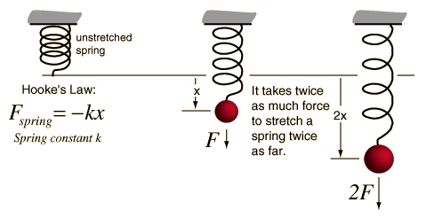

Procedure:
- Google “phet” and click on “Physics”
- Find and click on the “Masses and Springs” simulation. (Hint: the simulations are in alphabetical order)
- Click on the green button. If that doesn’t work, and run the sucker. (click ‘yes’ to any annoying pop-ups, everything is safe)
- The masses can be dragged around and hung from the springs. Play around with this feature for a while. To remove the weights from the spring, click on them and drag them to the right or left.
- While you’re at it, play around with the different settings in the big box at right. Notice that the stiffness of the Spring 3 can be changed. Make sure to adjust the time settings while you have the spring oscillating as this will be important later. You can also move the ruler around which will also come in hand in a bit.
Part One – Determining the Spring Constant for an Unknown Spring
- Now that you got all of the playing around out of your system it’s time to get to work! Remove all masses from springs and change the settings to match these:
  - friction: lots
  - softness of spring 3: see step 2
  - Show Energy of: No Show
  - real time: checked
  - Earth: checked
  - Stopwatch: unchecked
  - Sound: doesn’t really matter
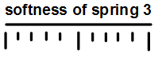
- You will be using only spring 3 for now. Call Mr. G over and he will give you one of the settings for the ‘softness of spring 3.’ Circle it on the diagram to the right.
- Take note of the position of the horizontal line on the bottom on the spring before any mass is suspended from it. It should be lined up with the black, horizontal dashed line. If it is not, then all laws of Physics have broken down and it will be pointless to go any further. If it is, this is the equilibrium line from which you will use the ruler to measure the displacement of the stretched spring from equilibrium, a.k.a. your ‘x’ value.
- Fill in the table below using each of the labeled masses and the ruler. Remember that centimeters and grams are the Justin Biebers of the science world. . . nobody likes them! Use g = 9.8 ^{m}/s² for gravity.
mass (g) | mass (kg) | Force/Weight (N) | x (m)
50
100
250

- Choose an appropriate scale and plot a Force vs. Displacement graph (that’s Force on the y-axis and Displacement on the x-axis) using your data from the previous step.

- Calculate the slope of the line created from your data, assuming you took your data correctly and the line is fairly straight. A ruler might help.
Slope Calculation:

- What did you just find by calculating the slope above? (Hint: look at the units)

- Calculate the spring constant mathematically using Hooke’s Law and your data for the 250 g mass:
Spring Constant Calculation:

- How do your slope and calculated values compare?

Part Two – Finding the Unknown Masses

- Now that you have your value for your spring constant for spring 3, use it to find the magnitude of the masses of the unknown weights. Use the data table below for your measurements and avoid any fat jokes about the red mass, he’s a little sensitive. Also, find the potential energy stored in each spring while each of the weights are being hung. Show ALL of the calculations you used to solve for the mass of one of the unknowns in the space provided below the table.
Unknown Mass Color | x (cm) | x (m) | F (N) | mass (kg) | PE_{sp} (J)
Green
Gold
Red
value for k for spring 3 =

Calculations:

Mass Color- _________________

Part Three – Finding the Period of Oscillation
- Calculate the period of oscillation for a spring mathematically by using the equation below, the 100-g mass, and your value for k:

 | $$T=2π\sqrt{\frac{m}{k}}$$ | - (2)

Period Calculation:

- Now the hard way. Keep all simulation settings the same except change ‘friction’ to ‘none,’ turn on the stopwatch and click ‘pause.’
- Hang the 100-g mass from spring 3 and compress the spring by 10 cm (be sure to take your measurements from the equilibrium line to the red horizontal line of the spring).
- Drag the stopwatch close to where your weight is being magically held on the compressed spring and click start on it. It should not begin to count time since the simulation is paused.
- Once you unpause the simulation the weight will begin to oscillate and the stopwatch will start to run. Measure the time it takes to complete one complete oscillation and record your data in the provided table (Hint: use ‘1/16 time’ rather than ‘real time’ click ‘pause’ at the end of one complete oscillation).
- Do this a total of five times. Find the frequency for each trial as well.
- Find the average period of oscillation and average frequency and record them in the table.

Trial # | T (s) | f (Hz)
1
2
3
4
5
Average Period = _________________
Average Frequency = _________________

- How does your measured value of period compare to your calculated value?

