Nuclear Fission Simulation
Name: Period:
Open the “Nuclear Fission” sim: http://phet.colorado.edu/simulations/sims.php?sim=Nuclear_Fission
Start at the tab “Fission: One Nucleus”
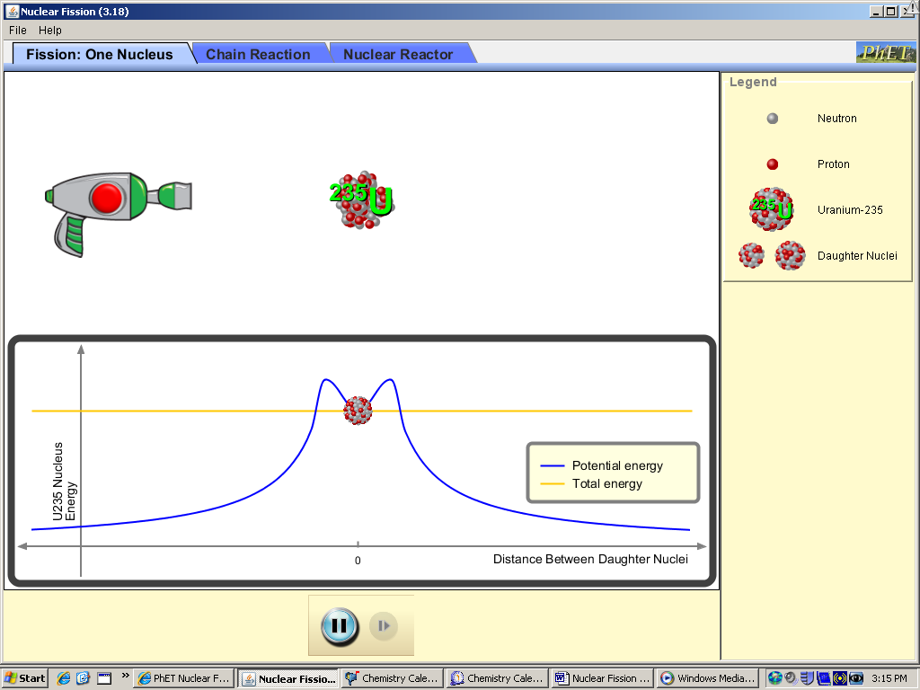
#1) Define fission: ________________________________________________________________________________________________________________________________________________
#2) Run the simulation. Before the gun is fired, is the material stable, or does it seem likely to radioactively decay?
________________________________________________________________________________________________________________________________________________________________________________________________________________________
#3) When you operate the gun, what type of particle does it fire?
________________________________________________________________________________________________________________________________________________________________________________________________________________________#4) If the gun fires and “hits” the nucleus, what happens?
________________________________________________________________________________________________________________________________________________________________________________________________________________________
#5) Switch the tab to “chain reaction” and add some uranium-238. The atom used in the previous tab was uranium-235. Is uranium-238 “fissionable”? How does firing the gun on a uranium-238 atom change it? (Note you can aim the gun.)
________________________________________________________________________________________________________________________________________________________________________________________________________________________
#6) Reset the sim (using the button) and add lots of fissionable (≈ 50) uranium-235. What happens and why?
________________________________________________________________________________________________________________________________________________________________________________________________________________________
#7) Normal levels of the uranium-235 isotope are about 0.72%, with the majority being uranium-238. Round the level up to 1% (in the favor of uranium-238), to one atom of uranium-235 and 99 atoms of uranium 238. Use the simulation to discover if naturally-derived uranium can start a chain reaction (and therefore be useful in either nuclear weapons or nuclear power plants): Is naturally derived uranium able to start a chain reaction, or must the sample be “enriched”?
________________________________________________________________________________________________________________________________________________________________________________________________________________________
#8) Use the simulation to find a minimum ratio of uranium-235 to uranium-238 (keep your total of atoms always at 100); what is the smallest percentage that still starts a chain reaction?
________________________________________________________________________________________________________________________________________________________________________________________________________________________#9) How does the above compare to “weapons-grade” enriched uranium (about 80-85%)?
________________________________________________________________________________________________________________________________________________________________________________________________________________________
#10) Use the simulation to make a nuclear weapon. What conditions are needed? (Hint, you’ll need to check the box “containment vessel”, and a certain level of enrichment that you must determine.)
________________________________________________________________________________________________________________________________________________________________________________________________________________________#11) What is a “dirty-bomb” (you may have to look it up online). Is a high grade of uranium needed for a dirty-bomb to explode? ________________________________________________________________________________________________________________________________________________________________________________________________________________________
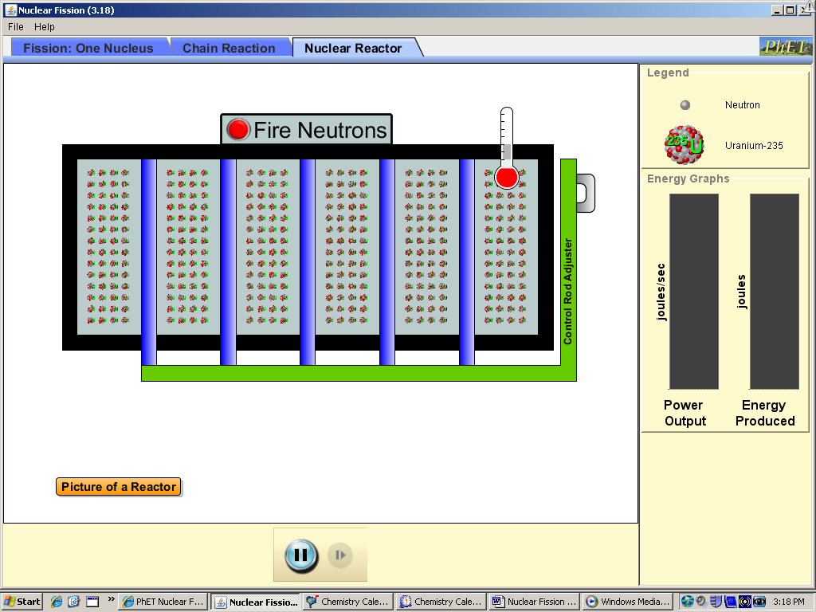
Nuclear power plants:
Switch to the “Nuclear Reactor” tab.
#12) What is needed to start the nuclear reactor?
________________________________________________________________________________________________________________________________________________________________________________________________________________________#13) What does adjusting the control rods do? What is their apparent function?
________________________________________________________________________________________________________________________________________________________________________________________________________________________#14) Without the control rods in position, what happens?
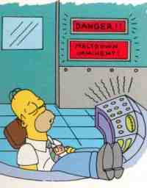________________________________________________________________________________________________________________________________________________________________________________________________________________________#15) Homer Simpson is asleep at the Springfield Nuclear Power Plant (where he’s known to occasionally work.. although mostly he’s asleep at the controls). When the power plant sounds an alarm (d’oh!), what is happening, and what must Homer do to save the day? ___________________________________________________________________________________________________________________________________________________

