Our Bodies' Velocities, By the Numbers

Neural signals zip through our brains. Cells produce proteins faster than a blink. We are creatures of varying velocities.

By Bob Berman
Wednesday, June 04, 2014
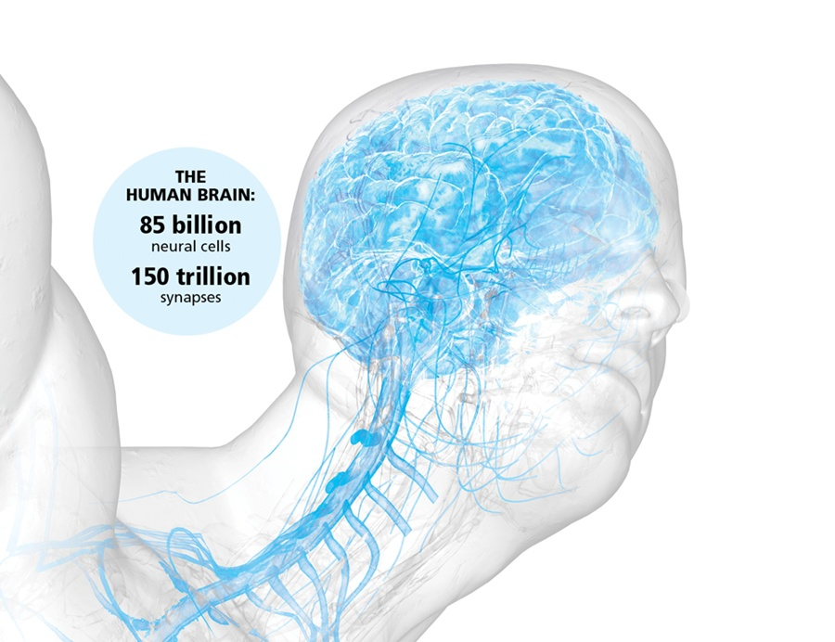

Jeong Suh, Bryan Christie Design

“Sorry, I’m busy right now,” you tell a friend. That’s so true. For its size, your body is as busy as the galaxy.
Even when we’re resting and daydreaming, internal activity is nonstop. The brain, of course, is the crown jewel of our nervous system. It has 85 billion neural cells and 150 trillion synapses. These are its electrical connections, its possibilities. This figure is nearly a thousand times as great as the number of stars in the Milky Way.
The number of brain neurons is impressive. To count them at the rate of one a second would require 3,200 years. But the brain’s synapses, or electrical connections, are beyond belief. Those 150 trillion could be counted in 3 million years. And that’s still not the end of the matter. What’s relevant is how many ways each cell can connect with the others. For this we must use factorials. Let’s say we want to know how many ways we can arrange four books on a shelf. It’s easy: You find the possibilities by multiplying 4×3×2 — called “4 factorial” and written as 4! — which is 24. But what if you have 10 books? Easy again: It’s 10! or 10×9×8×7×6×5×4×3×2, which is — ready? — 3,628,800 different ways. Imagine: Going from four items to 10 increases the possible arrangements from 24 to 3.6 million.
Bottom line: Possibilities are always wildly, insanely greater than the number of things around us. If each neuron, or brain cell, could connect with any other in your skull, the number of combinations would be 85 billion factorial. This winds up being a number with more zeroes than would fit in all the books on Earth. And that’s just the zeroes after the 1, the mere representation of the number, not the actual count. The brain’s connection possibilities lie beyond that same brain’s ability to comprehend it.
All this architectural complexity may seem to lie inertly like a 3-pound lump of cheese with the same volume as a 1,400-cc motorcycle piston. Since the brain has barely more density than water, it does indeed appear to be a mushy, unimpressive lump. Its animation is utterly disguised. Making the brain vibrant are its relentless electrical activities. Unseen sparks fly everywhere. Each neuron functions on about 100 millivolts. A tenth of a volt is darned efficient. Even if you add up the brain’s entire energy consumption, it’s a mere 23 watts (for a typical person consuming 2,400 calories daily). Still, the brain uses a whopping 20 percent of the body’s energy despite taking up only 2 percent of the body’s mass. It’s an energy hog, and there’s no “off” switch; the current courses continuously.
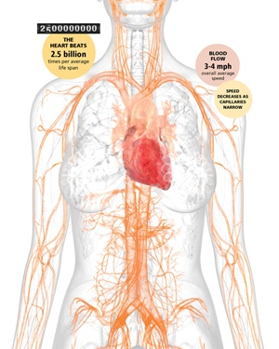

Jeong Suh, Bryan Christie Design
Faster Than a Speeding Brain
Electricity travels through a copper wire at 96 percent the speed of light. No such luck when it comes to neural strands. Our body’s neurons come in several different varieties and capacities, but none lets current flow even 1 percent as swiftly as in an electric can opener. Yet we apparently don’t need such light-speed cognition to accomplish everyday mental brilliancies like bagging the garbage. Our actual maximum operating rate of just 390 feet per second, or less than a millionth of light speed, is fast enough to do the job.
This is obvious with a quick experiment. Close your eyes and rapidly flail a hand — over your head, to the sides, anything. You’re always aware of exactly where it’s located, every moment, no matter how quickly you alter its position. Your in-the-moment cognizance of your hand’s location proves that neural signals must reach your brain extremely quickly. In fact, those impulses travel faster than 250 mph.
That’s the nerve transmission speed for essential stuff. But what qualifies as “essential?” Fortunately, you don’t have to personally prioritize the relative importance of all the sensory, muscular, pressure, pain and other inputs. It was taken care of, designed and hardwired before you even left the womb. A friend’s carelessly exuberant hand gesture is about to poke your eye? You instantly blink and evade. You’re eating and would prefer not to stab yourself with the fork? The positional signals from your fingers and lips are in-the-moment. On an overnight camping trip, stepping out of the tent barefoot, you tread on a suspicious object that feels an awful lot like a snake? You yank your leg up in an eyeblink. All these reflexes were neurally commanded at 250 mph.
But now stub your toe. Or just remember when you did. It took several seconds to feel any pain. That’s because pain signals travel along separate cables at a low-priority speed of just 3 mph. There’s no rush to deliver bad news.
Meanwhile, thinking signals occur at an in-between speed. They slither and branch through the cerebral cortex at 70 mph.
All these fast, slow and intermediate electrical impulses and synaptic connections happen continuously, with their pace peaking in the morning. We get a break only when the lights go out: The brain operates at a much-reduced level when we’re asleep.
The nervous system’s activity, which peaks between ages 22 and 27 and starts to diminish thereafter, is of course the control system for a myriad other internal motions. The well-known ones are our breaths and heartbeats.
The heart beats 2.5 billion times in a lifetime. The 5 quarts of blood an adult male continually pumps (4 quarts for women) flow at an average speed of 3 to 4 mph — walking speed. That’s fast enough so that a drug injected into an arm reaches the brain in only a few seconds. But this blood speed is just an average. It starts out by rushing through the aorta at an impressive 15 inches a second, then slows to different rates in various parts of the body.
Normally, liquids like water speed up when forced to flow through a narrower pipe. Kids like to squeeze a hose to make the water jump farther, to douse their friends. But the opposite happens in the narrow capillaries. Here is where blood flow is slowest.
It’s all part of the oxygen-exchange plan. The reason goes beyond the fact that capillaries are farthest from the heart. Rather, there are so many of them that their cross-sectional area is greater than what’s found in veins and arteries. The blood volume is essentially spread out there.
Lymph fluid moves through its own system of channels, at the low speed of a quarter-inch a minute. But air is much livelier. Men and women normally inhale and exhale about a pint of air — half a quart — 12 or 15 times a minute. This adds up to an air intake just shy of 2 gallons a minute. To make this happen, the lungs and diaphragm move in and out an inch a second.
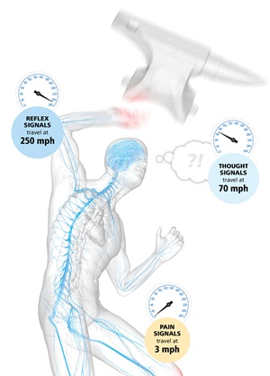

Jeong Suh, Bryan Christie Design
What Goes In …
Meanwhile, we pop a pastry into our mouth and chew with lower teeth performing all the motion, rising and falling at the rate of an inch a second. (Studies show that more saliva squirts out when we’re hungry.) Gulp, and down she goes, and now we rely on esophageal peristalsis, a wave of contractions that brings the food stomach-ward at the speed of ¾-inch per second.
Splash — into the tummy. There it remains for an average of two to four hours.
Next, the food is additionally processed, together with water removal, as it chugs growlingly through the 20-foot-long small intestine and then the 6-foot large intestine. This mass barrels along at a speed that varies from a foot an hour to a foot every three hours. It depends on the person and also on the food. Stuff with a lot of roughage moves fastest. And fully half the weight of stool is bacteria. Indeed, research in 2012 revealed that about 3 percent of each of us is pure bacteria. We’re each an “us” rather than an “I.”
The entire process — in one end and out the other — can be over in a single day. Or it may require three days. There’s no “normal” here, despite everyone having some opinion of how often they should go to the bathroom. Some individuals have bowel movements three times a day. Others just once every other day. If you want to speed things up, increasing dietary fiber to 25 grams or more a day is the best method. We cannot control our neuron electrical speed, lymph fluid rate, airflow exchange or capillary blood flow velocity. Nor can we alter the speed of asteroids. In the personal digestive realm alone do people wish to become control freaks to obtain what they imagine to be optimum velocity.
Same with urination. Men and women, big and small, all pee at the same average rate — between ¹/₃ and ½ ounce per second. Since the mean urine quantity is 1 to 2 quarts a day, we are condemned to spend one to two full minutes on daily peeing. Rarely more than three. The average woman urinates eight times a day, the average man seven times, though up to 13 times is not, believe it or not, considered abnormal. Adding it all up, a person who urinates seven times daily will require between nine and 27 seconds to do the job per session.
We thus dedicate an entire month of our lives to this activity.

Something to Sneeze At
Men and women blink at the same rate, too. That is, about 10 times a minute, or once every six seconds. Staring — like when reading — counterintuitively cuts that rate in half. But while extended focusing on one visual task makes us blink less, being tired does the opposite, and creates more blinking.
Each blink takes just a tenth of a second. The instigation of the eyeblink is even faster than the blink itself. The human eye’s reflex elicited by an air puff is 30 to 50 milliseconds, better than one-twentieth of a second. Compared to that, voluntary reaction time to a visual “act” signal in a laboratory, even when the subject is keyed up and expecting it, is around one-seventh of a second. In a road situation, it would take an additional three-quarters of a second for a driver to move her foot from the gas pedal to the brake. Conscious choices may be overrated. Reflexive actions are the way to go.
Consider that within each cell, protein synthesis creates new substances, each with a particular vital function. How fast? A cell’s ribosomes can make a disease-fighting protein in 10 seconds. Given the millions of cells all simultaneously producing proteins to combat an infection, it’s very long odds against any given invading bacterium ever gaining a foothold.
Good thing. These armies are often evenly balanced. A colony of bacteria can double its size in 9 minutes and 48 seconds. We’ve all experienced boils and other germ cities that temporarily manage to get the upper hand against our defenses.

Body of Numbers
- Lymph fluid moves at ¹⁄₄ inch per minute
- Air intake averages 2 gallons per minute
- Food travels through the esophagus at ³⁄₄ inch per second
- Urine flows ¹⁄₃-¹⁄₂ ounce per second
- Blinking takes ¹⁄₁₀ second and happens about 10 times per minute
- A cell can make a protein in 10 seconds
- The fastest sneeze was recorded at 102 mph
Our fastest movements are involuntary. One of these is legendary: the sneeze. Yet it usually begins in slow motion. The first phase of the sneezing reflex is a nasal tingling after it’s been stimulated by a chemical or physical irritant. Or, sometimes, by a strange bright-light response called the photic sneeze reflex, when people emerge from a movie matinee into brilliant sunshine. Whatever the basis, the initial odd tingling grows until it reaches a level that triggers the far more animated second act.
It’s this so-called efferent or respiratory phase that consists of eye closing, sudden uncontrollable deep in-breath, and then blowing out air while closing the throat and increasing air pressure in the chest. The reflexive sudden opening of the throat releases a supernova air rush through the mouth and nose, explosively expelling any irritants.
A sneeze can release 40,000 particles at high speed. What speed is it, exactly? You’ll find all sorts of disparate velocity figures on the web. Some claim that this is the only body event that breaks the sound barrier. The truth, while still impressive, doesn’t come close to such a 768-mph achievement. The TV show MythBusters actually measured sneezes; their subjects’ fastest was 39 mph. In a medical setting and using trustworthy equipment, the fastest recorded sneeze was 102 mph. For some reason, Guinness World Records lists the greatest sneeze a bit slower than this, at 71.5 mph, or 115 kph. Definitely fast enough to count as the highest-velocity body motion.
A long-standing puzzle is why sneezers are forced to close their eyes during the event. The best guess is that we are then protecting our eyes from the ultrafast spray of sneeze germs and particles. Another possible reason is that a sneeze is a unique reflex that involves nearly the entire body. Many muscles contract in the nose, throat, abdomen, diaphragm, all the way to the back and even the sphincters. This is why people with “weak bladders” may release a bit of urine during a sneeze. So the eyes closing is just part of a much larger, unique display of physiological violence.
It all originates in a part of the brain stem called the medulla oblongata, which is present in countless other animals that sneeze pretty much the same way we do. So we just can’t escape this hurry-up universe. We can’t even avoid it by staying in bed.
We take it with us, inside our skulls and under our skin.

