Pendulum Lab
Purpose:
Determine the relationship between Gravitational Energy and Kinetic Energy when using a pendulum.
Measure the following:
Mass of weight______ kg
Diameter of mass _______ m
Solve for the velocities at the bottom of the swing for three heights. Hints: E_{g}=mgh E_{k}=.5mv²
(a) h = .04 m (b) h = .08 m (c) h = .16 m

Record your solutions as ‘theoretical velocity’ in the data table below.
Fill in the data table below by pulling the bob back to each of the heights listed. The photogate will be needed to determine ‘experimental velocity’.
Condition | Height (m) | Experimental Velocity (m/s) | Theoretical Velocity (m/s)
1 | .04
2 | .08
3 | .16

Calculate the percent error between the theoretical and experimental velocities:
(a) h = .04 m (b) h = .08 m (c) h = .16 m

____________% ____________% ____________%

What are some reasons the theoretical and experimental velocities may differ?
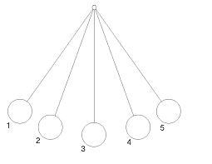

Pendulum at point 1 Pendulum at point 3 Pendulum at point 4

E_{K} E_{G}
E_{K} E_{G}
E_{K} E_{G}

Sketch the following qualitative graphs when the pendulum begins at the top of its swing:
Mechanical Energy v. Time Gravitational Energy v. Time Kinetic Energy v. Time

Time Time Time

