Virtual Capacitor Experiment – Name______________________________________________
Hand in at end of class for full credit.
This experiment should improve your familiarity with capacitors and enable you to appreciate what happens when you change the physical characteristics of a parallel plate capacitor.
Open the following webpage, and then click on the “Run Now” button
http://phet.colorado.edu/en/simulation/capacitor-lab

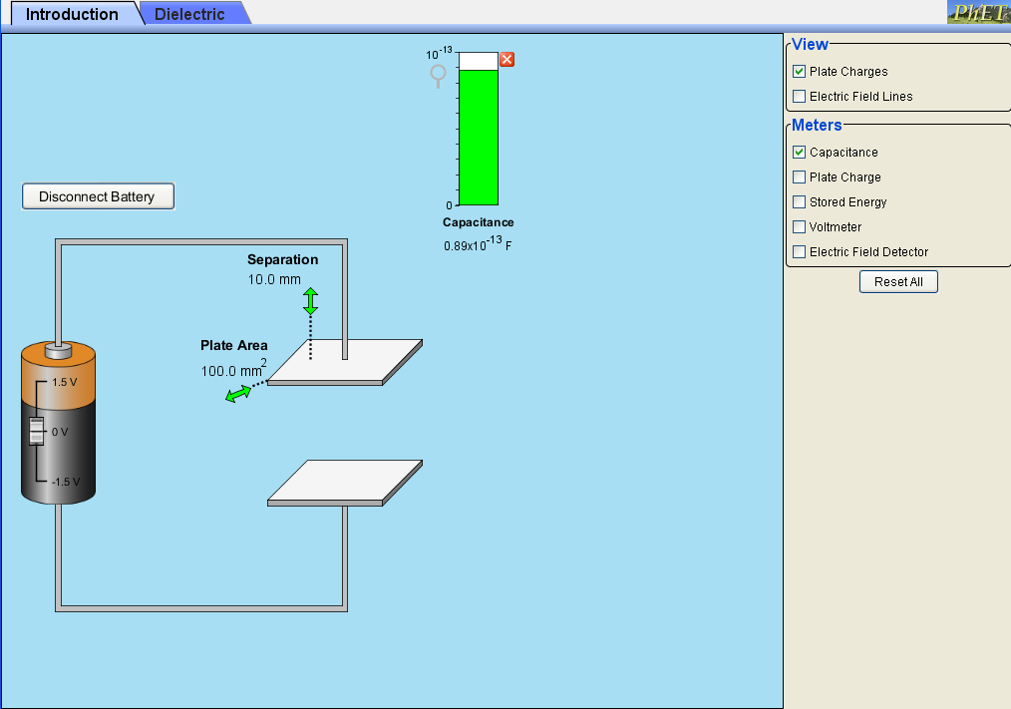
The following window should appear.
- Using the default separation and plate area, adjust the battery between -1.5 V and 1.5 V. Write down your observations.
- Now connect the meter marked “Plate Charge”, and the Voltmeter You’ll need to connect the voltmeter to the plates. Repeat the first procedure, and make three measurements of Charge Q, and the corresponding voltage V.
Q /coulombs
V/volts
Capacitance / F
Verify that the capacitance agrees with your measured values of Q and V. Show your working.

- Now we’re going to investigate what happens when we change the dimensions of our capacitor. Firstly, disconnect all meters and the battery.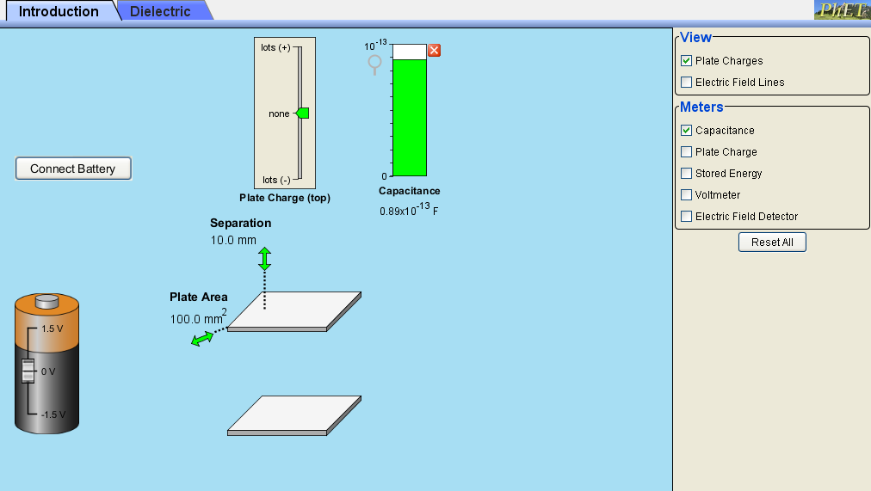
a) Vary the area of the plates. How does the Capacitance vary with area A? Show your calculations below
b) Vary the separation of the plates. How does the Capacitance vary with the separation d. Show this below.
Write down an expression for the capacitance of a parallel capacitor, and calculate the constant of proportionality, ε₀.
- Reconnect the battery and adjust to 1.5 V. Check the View “Electric Field Lines” box, and the Charge meter box. With the battery connected, watch what happens when the separation of the plates is increased.
- What happens to charge when the plate separation is increased, and why? (Please take note of any charge flow)

- What happens to the strength of the field when the separation is increased, and why?
- With the separation 5 mm, disconnect the battery.
- What happens to charge when the plate separation is increased, and why?
- What happens to the voltage when the plate separation is increased, and why?
- What happens to the strength of the field when plate separation is increased? (You can use the field meter to check this.
- Repeat experiment 5) a) but now use the stored energy meter. Why do you think the change takes place.
Where does this energy come from / go to?
- Now repeat 6, but with the battery connected.
Harder question. Do you think that mechanical work had to be done to increase the separation of the plates. If so, how do you reconcile this with the fact that the energy stored DECREASED when you increased separation.

