Purpose: Use this simulation to observe changes that occur in a circuit as time passes.

a. Observe changes in the current during charging and discharging.

b. Observe changes in the voltage across a resistor during charging and discharging.

c. Observe changes in the voltage across a capacitor during charging and discharging.

**Procedure and questions**

1. Access the **PhET** web site.

2. Click on **Simulations**.

3. From the left hand menu pick **Electricity, Magnets, and Circuits**.

4. Choose **Circuit Construction Kit: DC & AC (Direct Current & Alternating Current)**

5. Select **Upload** and navigate to the **Teacher’s Directory** to find the file I stored as

**R-C Circuit Simulation.** It should look like the screen picture shown below. You may have to replace the red and black voltmeter connections to the proper location in the circuit.

a. Charge the capacitor by closing the switch on the left.

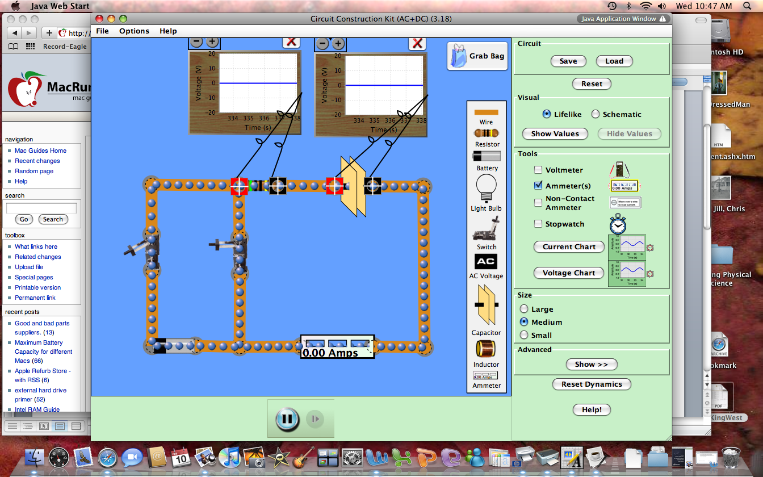

Resistor Voltage

Capacitor Voltage

time

time

Sketch the graphs of Voltage vs. Time for the resistor and the capacitor below.

b. What happens to the current through the circuit as time goes on?

c. What happens to the amount of charge on the capacitor as time goes on?

d. Now discharge the capacitor by opening the switch on the left and closing the switch on the right. Sketch the graphs of Voltage vs. Time for the resistor and the capacitor below.

Resistor Voltage

Capacitor Voltage

time

time

e. What happens to the current

through the circuit as time goes on?

f. What happens to the amount of

charge on the capacitor as time

goes on?

g. Predict the changes to the graphs if the amount of resistance increases by drawing additional lines on your graphs above. Explain the reasons for your predictions.

h. Right click on the resistor and increase the resistance. Use another color to show the results on your charging and discharging graphs above.

i. Predict the changes to the graphs if the amount of capacitance increases. Use the graphs drawn below to show the original graphs and the changes that you predict. Explain the reasons for your predictions.

Resistor Voltage

Capacitor Voltage

time

time

h. Right click on the capacitor and increase the capacitance. Use another color to show the results on your charging and discharging graphs above.

i. What happens to the current through the circuit as time goes on?

j. What happens to the amount of charge on the capacitor as time goes on?

k. What is the function of a resistor in a circuit? How does it affect the amount of charge that flows? How does it affect the rate at which charge flows? How does it affect the initial and final voltage across the capacitor?

l. What is the function of a capacitor in a circuit? How does it affect the amount of charge that flows?

How does it affect the rate at which charge flows? How does it affect the initial and final voltage across the resistor? How does the capacitor make charge move when there is no battery in the circuit?

**Purpose:** How does placing more than one capacitor affect voltage drops and charge stored in a circuit?

Select **Upload** and navigate to the **Teacher’s Directory** to find the file I stored as

**R-C Circuit Simulation II.** It should look like the screen picture shown below. You may have to reconnect the voltmeter.



a. Close the left hand switch to charge the capacitors.

How does the voltage drop across each capacitor compare?

Check the value of the batteries voltage by right clicking on it. How does the voltage drop across each capacitor compare to the voltage across the battery?

Discharge the capacitors by opening the left switch and closing the right switch. Increase the capacitance of the top capacitor. Repeat the charging process. How does the voltage drop across each capacitor compare?

What is the relationship between the size of the capacitor and the share of voltage it receives?

Does it appear that placing two capacitors in a circuit with one pathway (series circuit) for charge increases or decreases the amount of charge stored? You may need to return to the original circuit from part I to decide.

Select **Upload** and navigate to the **Teacher’s Directory** to find the file I stored as

**R-C Circuit Simulation III.** It should look like the screen picture shown below. Check the voltmeter connections again.



a. Close the bottom switch to charge the capacitors.

How does the voltage drop across each capacitor compare?

Check the value of the batteries voltage by right clicking on it. How does the voltage drop across each capacitor compare to the voltage across the battery?

Discharge the capacitors by opening the bottom switch and closing the top switch.

Increase the capacitance of the top capacitor. Repeat the charging process. How does the voltage drop across each capacitor compare?

What is the relationship between the size of the capacitor and the share of voltage it receives?

What is the relationship between the size of the capacitor and the amount of charge it stores?

Does it appear that placing two capacitors in a circuit with multiple pathways (parallel circuit) for charge increases or decreases the amount of charge stored? You may need to return to the original circuit from part I to decide.