RC circuits

PURPOSE: In this lab, you will explore how

- the charge and voltage on the capacitor change with time when a capacitor is charging or discharging
- the current in the RC circuit change with time when the capacitor is charging and discharging

This lab is based on Circuit Construction Kit simulator that can be accessed at

https://phet.colorado.edu/en/simulation/legacy/circuit-construction-kit-ac

Click on the picture to download the simulator file. You will be prompted to download Java in to open it.

It is recommended that you spend some time familiarizing yourself with the simulator before starting the actual lab. Construct a simple sample circuit (for example, consisting of a battery and a resistor, or a battery, resistor, and lightbulb) to explore how elements of the circuit connect. Note the following features:

- Once two elements of a circuit (such as two wires) are connected, you have to right-click on the junction to separate them
- Once each element of the circuit is selected and is on the “table”, you have to right-click on it to remove it. You can also adjust the properties of each element (resistance, voltage of the battery, etc.) by right-clicking on it.
Also, check out how voltmeter, ammeter and the voltage and current chart are used to measure voltage and current and their dependency on time.

DISCUSSION:

When a capacitor is connected to a battery or another source of an electromotive force (EMF) , the plates attain charge from the terminals of the battery until the potential across the capacitor equals the EMF of the battery. The rate of charging depends on capacitance C of the capacitor and load resistance R in the circuit.

For negligible resistance, the rate of charging is so quick that it looks instantaneous relative to the response time of most measuring devices. For large resistance, the process slows down as charge builds exponentially over time.

Discharging a previously charged capacitor with a wire of negligible resistance will likewise appear to be instantaneous, but it slows when a meaningful load resistance is used.

The rate of charging or discharging is characterized by the RC time constant given by

Assuming initially (at t = 0) the capacitor is uncharged, during charging, the charge on the capacitor changes with time as

$$q= q_{max }(1- e^{-\frac{t}{τ}})$$

The voltage between the plates of the capacitor is then

$$V = \frac{q}{c}= V_{max}(1- e^{-\frac{t}{τ}})$$

Here, $V_{max}$ is the voltage equal to the EMF of the battery, and $q_{max}=CV_{max}$ – the charge established on the plates of the capacitor when it is fully charged by the battery.

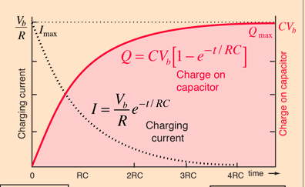

Source: http://hyperphysics.phyastr.gsu.edu/hbase/electric/capchg.html

During discharging, the charge on the capacitor changes with time as $$q= q_{max } e^{-\frac{t}{τ}}$$

The voltage between the plates of the capacitor is then

$$V = \frac{q}{c}= V_{max}e^{-\frac{t}{τ}}$$

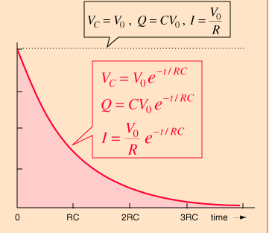

Source: http://hyperphysics.phy-astr.gsu.edu/hbase/electric/capdis.html#c2

Since the voltage depends on time exponentially, the linear relationship can be produced by taking a natural logarithm of the both sides of charging or discharging equation (as long as the exponent is isolated first).
Then, the time constant of the RC circuit can be obtained experimentally by plotting $\ln\left(1-\frac{V}{V_{max}}\right)$ vs time for the charging process, or $ln⁡(\frac{V}{V_{max}})$ vs time for the discharging process, performing linear regression (drawing the best-fit line), and using the slope of best-fit line to calculate the time constant.

What is the relationship of the slope of best-fit line and the time constant? It will be the same for either charging or discharging process.

PROCEDURE:

- The charging-discharging capacitor circuit is shown below:

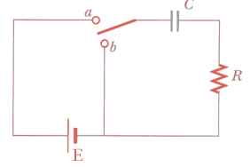
Note that when switch is position a, the capacitor is charging by the battery, and when the switch is the position b, the battery is no longer included in the circuit, and the capacitor will discharge.

Construct this circuit using the elements of the circuit in the simulator file:

10 V battery
25-Ω resistor
0.2 Farad capacitor

There is no three-way switch in the simulator, so use two switches and an extra wire instead. When switch a closed and switch b is open, the circuit should have the battery, capacitor and resistor in series. When switch b is closed and switch a is open, the circuit should have capacitor and resistor in series, with battery excluded. Insert the screenshot of your circuit below.

- Connect the voltage chart and current chart to the capacitor and practice charging and discharging the capacitor by closing and opening the switches. Observe how the voltage and current vary with time and make sure the graphs are consistent with theoretical expectations.

- Discharge the capacitor fully by right-clicking on it or clicking on “reset all dynamics” button. Remove the voltage and current charts and connect the voltmeter instead. Pay attention to the polarity so that your measured voltage is positive. Place a stopwatch in the corner of the screen.
- Open switch b and close switch a. Press “play” to start the charging process, pausing about every 10 seconds to take measurements of time and voltage. Take 6 to 8 measurements and record your results in the table 1.

Table 1.

t | V | $$\ln\left(1-\frac{V}{V_{max}}\right)$$

- Wait a few minutes until the capacitor is fully charged (the voltage is close to 10 V and stops changing). Reset the stopwatch. Open switch a and close switch b. Press “play” to start the discharging process and similarly take 6 to 8 measurements of time and voltage. Record your results in table 2.

Table 2.

t | V | $$\ln\left(\frac{V}{V_{max}}\right)$$

- Use Excel or other software of your choice to plot $\ln\left(1-\frac{V}{V_{max}}\right)$ and $\ln\left(\frac{V}{V_{max}}\right)$ using the data from the tables 1 and 2, respectively, on two separate graphs.

Use the best-fit line (also called trendline) to fit the data to the linear model. Insert the screenshots of your graphs below. They should contain:
- Labeled axes and units
- Data points and best-fit line (remember that the best-fit line does not necessarily go through all the points, but approximates the trend)
- Equation of the best-fit line

- Find the slope of each of the best-fit line and find the experimental values of the time constant using the relationship found in the DISCUSSION. Compare these to the theoretical value of the time constant for this circuit by finding percent error, and comment on the results.

