Name __________________________ Date_____________

Models of the Atom

- Describe briefly JJ Thomson’s model of the structure of the atom. Draw a labelled diagram.

___________________________________________

___________________________________________

___________________________________________

____________________________________________________________________________

Ernest Rutherford had already investigated the deflection of alpha radiation as it passed through very thin gold leaf. He hypothesised that atoms had a small positive charge concentrated in the centre. Together with his students Geiger and Marsden, at the University of Manchester, he conducted an experiment to test this hypothesis.

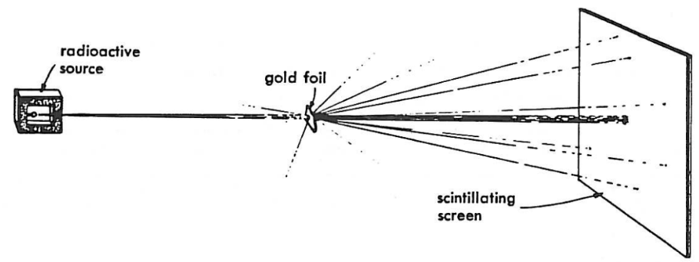 | 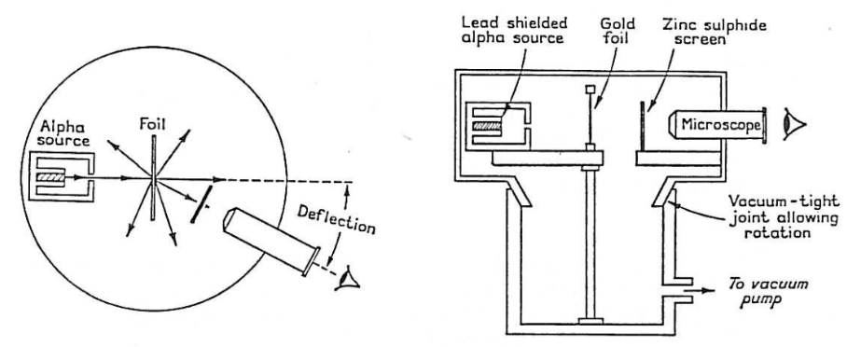
1909 | 1911

- Describe the 1911 Geiger and Marsden Alpha Scattering Experiment.

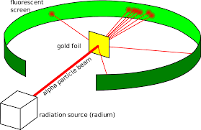 | _______________________________________  _______________________________________  _______________________________________  _______________________________________  _______________________________________  _______________________________________
http://large.stanford.edu/courses/2017/ph241/sivulka2/

Go to phet.colorado.edu. Once there, go to the Play with Simulations tab and click on the HTML5 tab. Scroll down and find Rutherford Scattering. When the new window pops up, click on the play button to open the simulation. Select the “Plum Pudding Atom”. Turn on the alpha particles (blue button). Click “Traces” box.

- Which model of the atom does this represent?

____________________________________________________________________________

- What type of path do the Alpha particles take? How does altering the energy of the alpha particle effect the direction of the paths?

____________________________________________________________________________

____________________________________________________________________________

Select the “Rutherford Atom”. Turn on the alpha particles. Click “Traces” box.

- The gold leaf experiment is set up and the atoms are shown with electron shells. What type of paths do most of the Alpha particles take?

____________________________________________________________________________

____________________________________________________________________________

- Compare the paths of the alpha particles in this model and the Plum Pudding atom.

____________________________________________________________________________

____________________________________________________________________________

____________________________________________________________________________

____________________________________________________________________________

- How does altering the energy of the alpha particle effect the direction of the paths?

____________________________________________________________________________

____________________________________________________________________________

____________________________________________________________________________

- Why do you think that our model of the atom changed after Rutherford’s experiment?

____________________________________________________________________________

____________________________________________________________________________

____________________________________________________________________________

____________________________________________________________________________

Select the nucleus box . Turn on the alpha particles. Click “Traces” box.

Alpha particles have a +2e charge (2 x 1.6x10⁻¹⁹ C) and gold nuclei have a +79e charge.

- Vary the energy of the alpha particles. Do any of the alpha particles collide with gold nuclei? What law appears to be describing the paths of the alpha particles?

____________________________________________________________________________

____________________________________________________________________________

____________________________________________________________________________

____________________________________________________________________________

- Describe the energy of an alpha particle as it approaches and is deflected by a gold nucleus.

____________________________________________________________________________

____________________________________________________________________________

____________________________________________________________________________

____________________________________________________________________________

- What would have happened if neutrons had been used in Rutherford’s experiment? Explain your answer.

____________________________________________________________________________

____________________________________________________________________________

____________________________________________________________________________

____________________________________________________________________________

  - What would have happened if aluminium had been used instead of gold in the alpha scattering experiment? Explain your answer.

____________________________________________________________________________

____________________________________________________________________________

____________________________________________________________________________

____________________________________________________________________________

  - Test your hypothesis by using the Atom box to change the metal (use the periodic table)

____________________________________________________________________________

____________________________________________________________________________

____________________________________________________________________________

____________________________________________________________________________

- How do you think Rutherford was able to estimate the size of the gold nucleus?

____________________________________________________________________________

____________________________________________________________________________

____________________________________________________________________________

____________________________________________________________________________

- What three properties of the nucleus can be deduced from the Rutherford scattering experiment? Explain your answer.

____________________________________________________________________________

____________________________________________________________________________

____________________________________________________________________________

____________________________________________________________________________

Answers and worked solutions
- The English scientist Thomson suggested that the atom, which is a neutral particle, was made of positive charge with ‘lumps’ of negative charge inset in it - rather like the plums in a pudding. For this reason it was known as the Plum Pudding theory of the atom.
- Alpha particles emitted toward very thin gold leaf in an evacuated vessel. The alpha particles were detected and counted using a scintillation screen mounted on an eyepiece. The angle of the eye piece was altered so that a count of alpha particles paths at different angles could be counted.
- Plum Pudding
- Almost completely straight, unaffected by the internal structure of the gold atom. Altering the energy of the particles makes little difference to their paths.
- Most pass through the atoms in straight lines. Some that pass near the centre of the atoms are deflected, the closer they get the larger the deflection. A small refraction rebound.
- In both models most of the alpha particles pass through un-deflected. Only in the Rutherford Model are the deflections significant or rebounds occur.
- At higher energies the deflections and rebounds become less pronounced. At lower energies the deflections and rebounds occur more frequently.
- The evidence of large deflections and reflections of alpha particles collected in the Geiger and Marsden experiment.
- None of the alpha particles collide with the gold nucleus (some get very close). The particles appear to be repelled by the charge of the gold nucleus. This suggested that Coulomb’s law would be used to describe the interaction.

Rutherford explained it this way. He knew that the alpha particles carried a positive charge so he said that the positive charge of the atom was concentrated in one place that he called the nucleus, and that the negatively charged particles, the electrons, were in orbit around the nucleus. Most of the mass was in the nucleus

- Kinetic energy is transferred to electrical potential energy by the field of the gold nucleus and then back to kinetic energy as it moves away.
- They would not have been repelled so it is unlikely that any would ‘bounce back’. Some could be absorbed by the nucleus.
- The charge on the nucleus is much smaller so deflection would be smaller.
- Rutherford’s prediction using the idea of Coulomb law repulsion was verified by experiment. It also enables experimental values of nuclear charge to be obtained, ie atomic number. By varying the kinetic energy of the alpha particles he was able to get closer and closer to the nucleus.
- Small, massive and positive.

References
Some sections of this worksheet uses the IOP TAP “Rutherford’s Experiment” collection of lessons https://spark.iop.org/collections/rutherfords-experiment

