Centripetal Force Slinky Lab
Slinkys can be used to demonstrate centripetal force. Newton's first law says that an object will continue in motion in a straight line unless a force acts to change the motion. When the motion of a Slinky is in a circle, the force is named the Centripetal Force. This Centripetal force is a part or component of the tension force that supports the slinky as it swings around in a circle and it equals:
F _{(centripetal)} = ((mass*velocity ² )/radius) = 4*(pi²)*mass*radius/T ²
In an experiment, one measures the angle of swing of the slinky [in this example about 40 degrees], the period or the time for one revolution, called T, and the radius.
the angle = _________________
the period, T = _____________
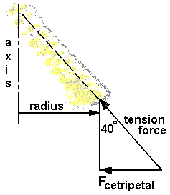
the radius, R = _____________
AN EXPERIMENT:
F _{(centripetal)} experimental = m*g*tan(angle)
F _{(centripetal)} theoretical = 4*(pi²)*m*radius/T ²
The mass, m, is the same in each case!
Does F _{(centripetal)} experimental = F _{(centripetal)} theoretical?
Show your work!

% of error = __________________

