Centripetal Force Slinky Lab
Slinkys can be used to demonstrate centripetal force. Note that the Slinky is a spring and obeys Hooke’s law. Newton's first law says that an object will continue in motion in a straight line unless a force acts to change the motion. When the motion of a Slinky is in a circle, the force is named the Centripetal Force. This Centripetal force is a part or component of the tension force that supports the slinky as it swings around in a circle.
Centripetal force can be calculated in various ways. In order to determine centripetal force from mass, radius length, and period the following steps need to be taken. Substitute the quantity ((2*pi*radius)/T) for velocity into the general formula
F _{(centripetal)} = ((mass*velocity ² )/radius) resulting in F _{(centripetal)} = 4*(pi²)*mass*radius/T ².
Experiment Part 1:
Measure the angle of swing of the slinky [in this example about 40 degrees], the period or the time for one revolution, called T, and the radius.
Angle = ______ Period or T = _______ Radius or R = ______ F _{(centripetal 1)} = ______
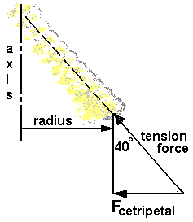
The length of the spring is affected by a tension force (resulting from both gravitational force in the y-direction and centripetal force in the x-direction). Hooke’s law proposes that the extension or compression of a spring is proportional to force. Given that k=.84 N/m and using Hooke’s Law (F = k*x), determine F _{(centripetal 1)} if R = x.
Experiment Part 2:
F _{(centripetal 2)} experimental = m*g*tan(angle)
F _{(centripetal 3)} theoretical = 4*(pi²)*m*R /T ²
Does F _{(centripetal 2)} experimental = F _{(centripetal 2)} theoretical?

Determine % Error = _____
Experiment Part 3:
Measure the mass of the slinky and determine F _{(centripetal 2)} and F _{(centripetal 2)} from part 2.
Mass: _________ F _{(centripetal 2)}:________ F _{(centripetal 3)}:_________
Which of the two new centripetal forces is closest to F _{(centripetal 1)}? Why?
____________________________________________________________________________________________________________________________________________
On the reverse side, please list at least three potential sources of error.

